**Sepuluh Query Bagian ke dua**

1. SELECT * FROM `pasien` ORDER by(id_alamat) DESC

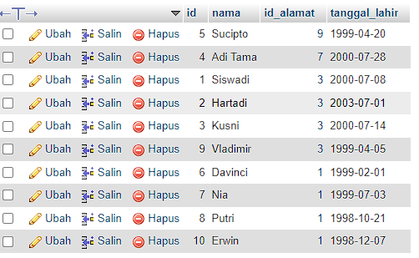

1. SELECT * FROM `pasien` ORDER by(id_alamat) ASC

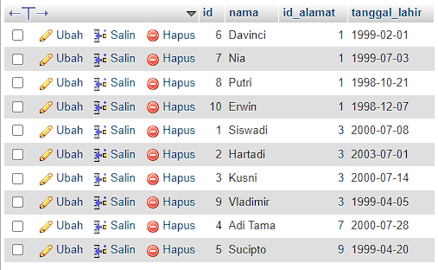

1. SELECT nama,tanggal_lahir FROM `pasien` where nama LIKE '%adi%'

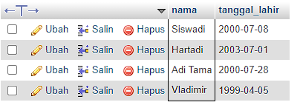

1. SELECT nama,tanggal_lahir FROM `pasien` where nama like '%ni%'

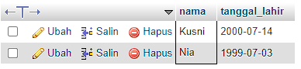

1. SELECT apoteker_id, SUM(jumlah) as total FROM `obat` GROUP BY apoteker_id

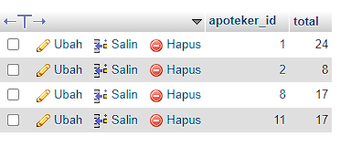

1. 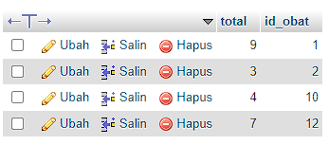SELECT sum(jumlah_obat) as total, id_obat FROM `transaksi` GROUP BY id_obat
2. SELECT sum(jumlah_obat) as total, id_pasien FROM `transaksi` GROUP BY id_pasien

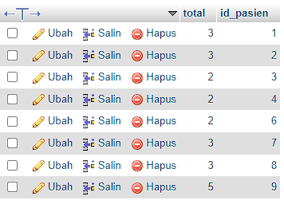

1. 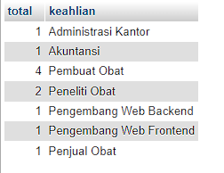SELECT COUNT(id_lulusan) as total, keahlian FROM apoteker GROUP BY keahlian
2. SELECT COUNT(id_lulusan) as total, keahlian FROM apoteker WHERE year(tanggal_masuk) > 2022 GROUP BY keahlian

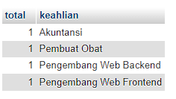

1. SELECT tanggal_kedaluarsa, SUM(persediaan) as jumlah FROM `obat` WHERE day(tanggal_kedaluarsa) > 18 GROUP BY tanggal_kedaluarsa ORDER BY tanggal_kedaluarsa ASC

